Project Design Phase
Solution Architecture
Solution architecture bridges the business problem and the technology solution. For this project, the architecture uses ServiceNow Incident form controls to enforce business rules at the client interface.
Goals for this solution:
• Control Incident field behavior according to Impact.
• Automatically update Urgency when Impact is High.
• Validate required information before an Incident is saved.
• Prevent unauthorized State changes through direct list editing.
• Provide a lightweight configuration suitable for a micro project.
Date | 3 October 2026
Team ID | SWTID-2026-9684
Project Name | Implement Client Script & UI Policy (Incident)
Maximum Marks | 2 Marks

Solution Architecture Diagram:
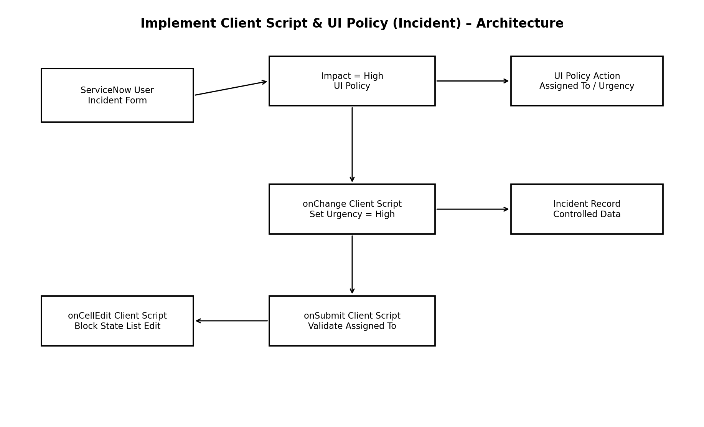
Figure 1: Architecture and control flow of the ServiceNow Incident configuration.

